Lab # 5
MADALINE (Multiple Adaptive Linear Neurons)

OBJECTIVE

To understand and implement the MADALINE (Multiple Adaptive Linear Neurons) algorithm, train it using a dataset, and evaluate its performance in classification tasks.

THEORY

Practical Significance:
MADALINE is an extension of the ADALINE (Adaptive Linear Neuron) algorithm, designed to handle non-linear classification problems by using multiple ADALINE units arranged in layers. It is one of the first examples of a neural network model capable of solving more complex problems than a single ADALINE. Understanding MADALINE provides insights into the evolution of neural network architectures and their capabilities.

Minimum Theoretical Background:

ADALINE Model Structure:
Consists of multiple ADALINE units in a layer, with possible multiple layers.

Activation Function:
Typically uses a step function for the output neurons.

Learning Algorithm:
Uses the Least Mean Squares (LMS) rule for training.

Mathematical Model:
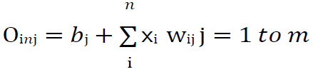
Here ‘b’ is bias and ‘n’ is the total number of input neurons.

Apply the following activation function to obtain the final output:

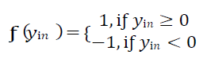
Output at the hidden Adaline unit Qj=f(Qinj)
Final output of the network y = f(yin)
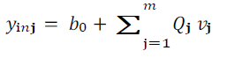

Adjust the weight and bias as follows:

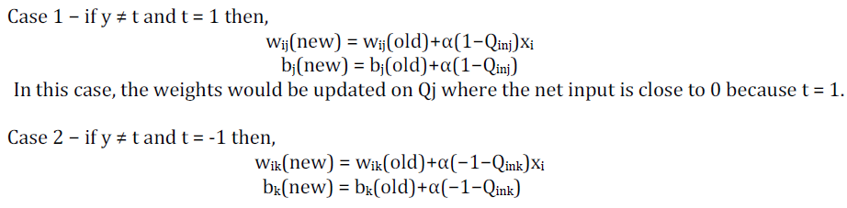

Here ‘y’ is the actual output and ‘t’ is the desired/target output.

LAB TASKS

Implement the MADALINE Algorithm:

Train on Non-linearly Separable Data:
- Create or use simple datasets (e.g. XOR gate, XNOR gate).
- Train the MADALINE on these datasets and evaluate its performance.

Visualize Decision Boundaries:
- Plot the decision boundaries of the trained MADALINE on a 2D plot with the training data points.

Experiment with Different Architectures:
- Modify the number of layers and neurons in each layer.
- Observe the impact on training time and accuracy.

LAB OUTCOMES

This lab provides hands-on experience with the MADALINE algorithm. By implementing and experimenting with MADALINE, students will understand how multiple ADALINE units can be combined to solve non-linear classification problems. This foundational knowledge is essential for building more complex neural network models and understanding the evolution of neural network architectures.

